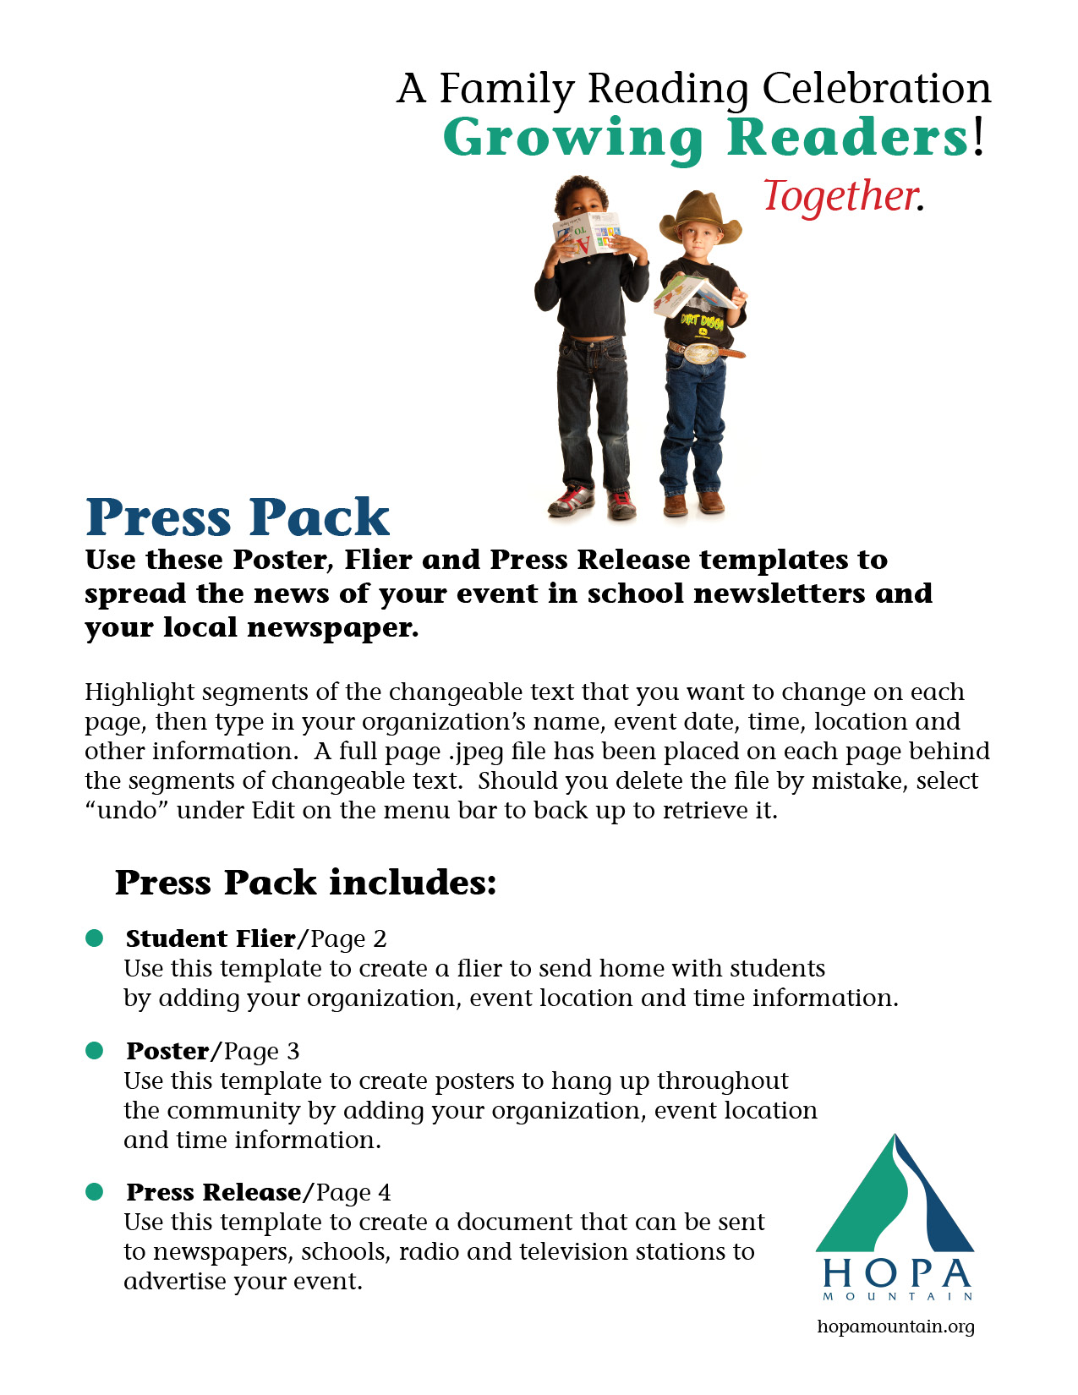



**Insert Organization Name**

**Insert Food Information here**

**Insert Contact Name, Phone and Email Address here**

**Insert Date of Event**

**Insert Time of Event**

**Insert Location of Event**

**Insert Address where event will be held and any special**

**Directions needed**

