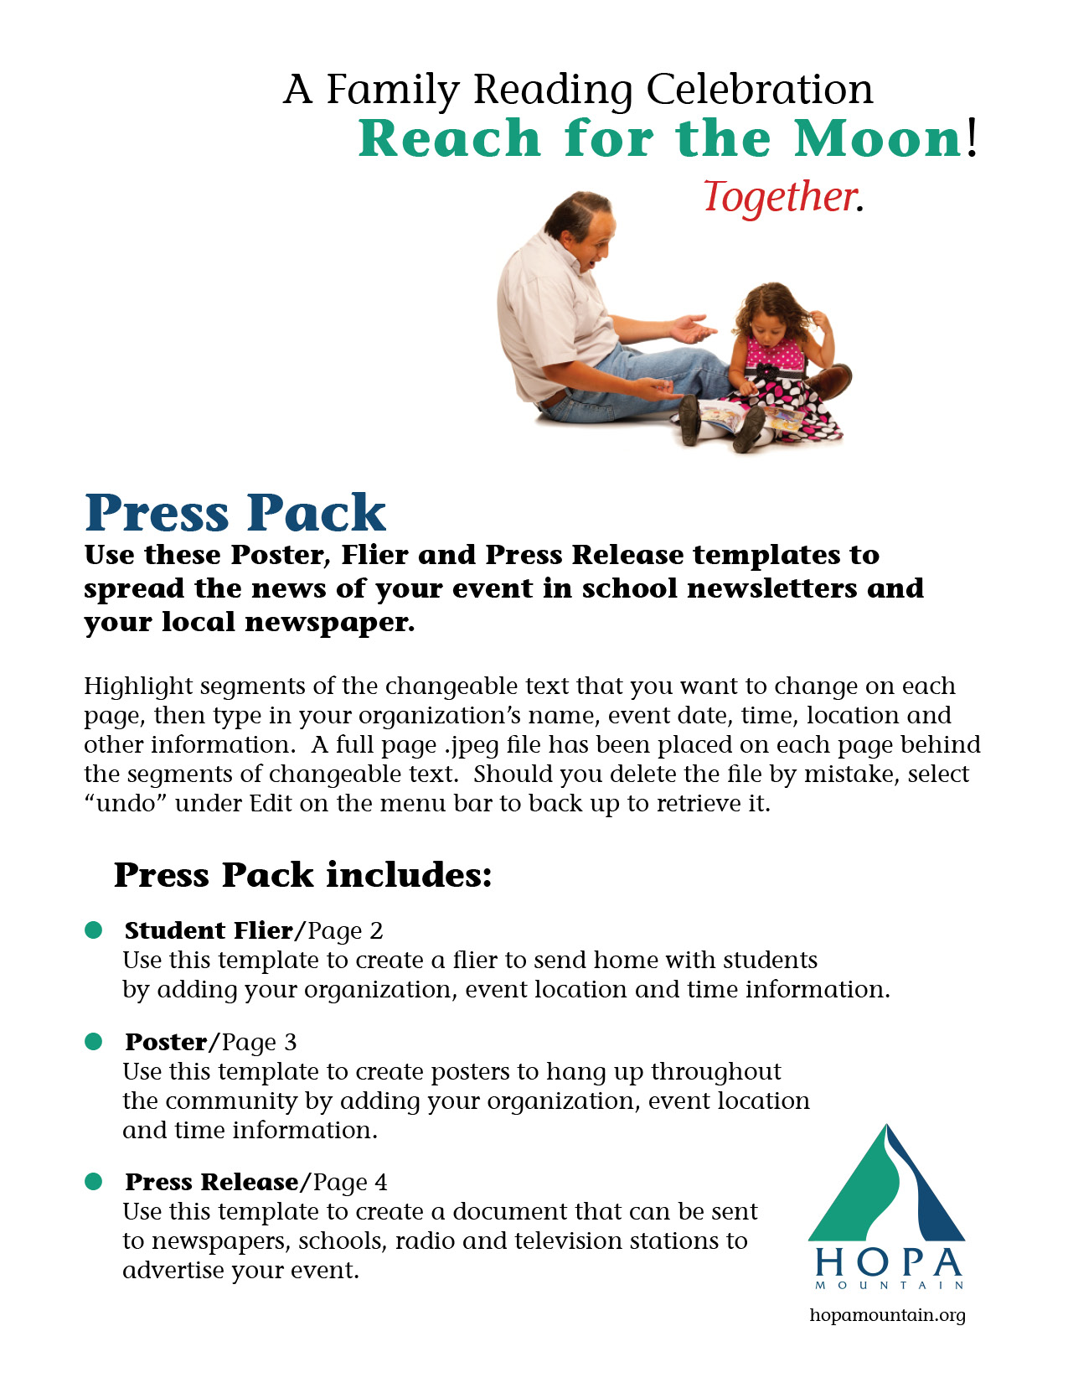
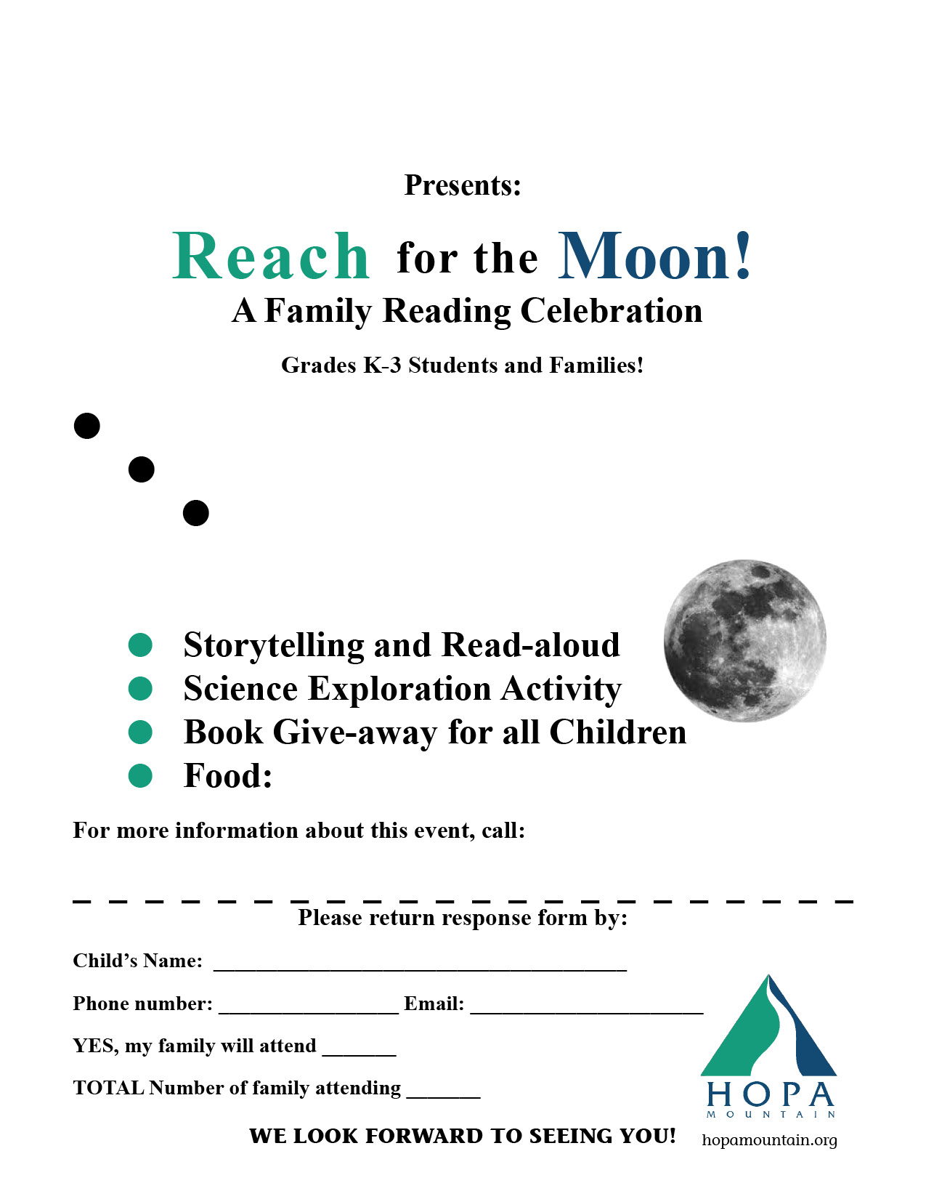

Insert Food Information here

Insert Contact Name, Phone and Email Addresses here
Insert Date of Event
Insert Time of Event
Insert Location of Event
Insert Organization Name

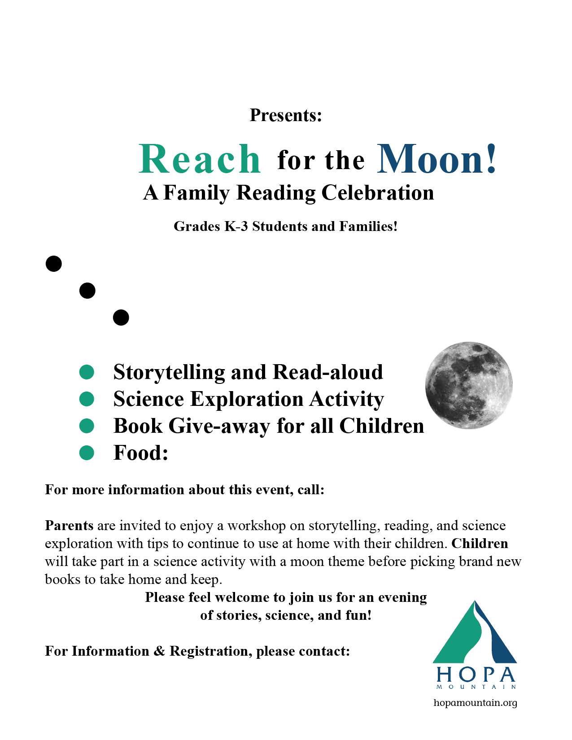
Insert Contact Name, Phone and Email

Insert Food Information here

Insert Contact Name, Phone and Email Addresses here
Insert Date of Event
Insert Time of Event
Insert Location of Event
Insert Organization Name

PRESS RELEASE
Reach for the Moon
A Family Reading Celebration

SUBJECT: A Family Reading Celebration will be hosted by [Your organization name].

CONTACT: [Insert your contact information here].

FOR RELEASE: On receipt
A Family Reading Celebration will be hosted by [your organization name].

[Insert your organization name here] will host Reach for the Moon! A Family Reading
Celebration on [insert date here]. Parents are invited to enjoy a workshop on storytelling, reading, and science exploration with tips to continue activities at home with their families.
When families interact positively together by talking throughout the day, reading and telling stories, and engaging in fun, imaginative play, their children are more likely to do well in school and lead happy, healthy lives. These nurturing experiences factor in healthy brain development and help strengthen the important bond that exists between children and their parents or caregivers.

During the Reach for the Moon! event, children will take part in a science activity with a moon theme before picking brand new books to take home and keep.

“By getting books in the hands of caregivers and children, we want to encourage rich early learning experiences at home that can make a big difference in the
development of a young child. Reading is just one kind of vital interaction — the key is positive language development through storytelling, singing or just talking together.”
- Bonnie Sachatello-Sawyer, executive director of Hopa Mountain.

A vast body of research has proven the many benefits of exposure to language—through talking, singing, and reading — on the developing brains of babies and children. Story time is also an important bonding time between parents and children.

Please feel welcome to join us for an evening of stories, science, and fun! Please call or email [insert your contact’s name and information].

